Executive Report: Automated Extraction of Pros and Cons
This report summarizes the findings from the machine learning analysis performed on the business document dataset. The objective was to determine how accurately a computer can distinguish between "Pros" (benefits/opportunities) and "Cons" (risks/costs) using various algorithms.
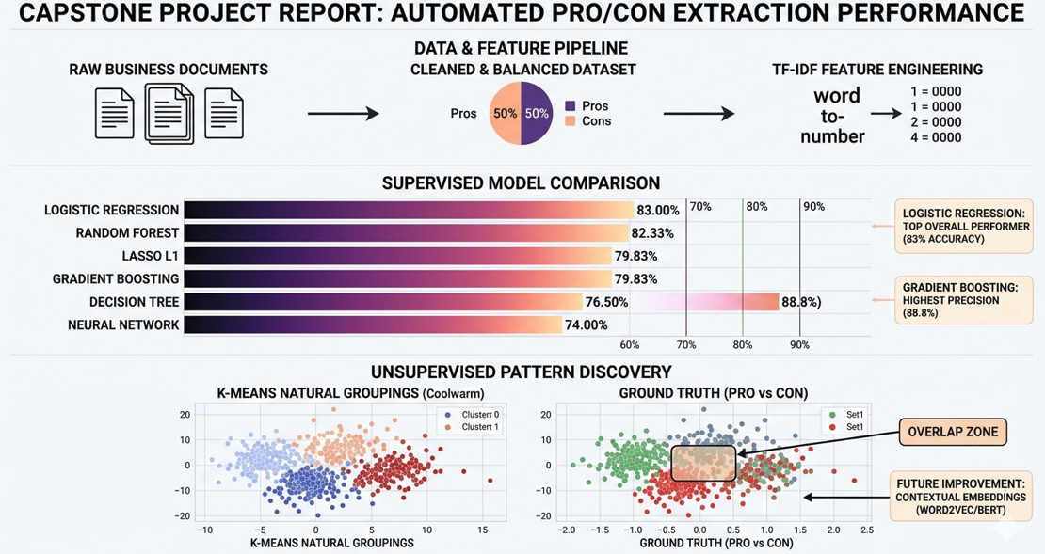

1. Data Overview & Class Distribution
The dataset was cleaned of empty entries and corrupted labels. The final analysis revealed a balanced dataset, with an almost equal split between "Pros" (1) and "Cons" (0).
- Insight: A balanced dataset is ideal for training because it prevents the model from developing a bias toward one category over the other.
2. Feature Engineering: Turning Words into Numbers
We used a method called TF-IDF (Term Frequency-Inverse Document Frequency).
- The Process: It transforms sentences into mathematical vectors by weighing words. Important words like "efficient" or "expensive" are given higher weight, while common words like "the" are ignored.
- Finding: We limited the analysis to the top 1,500 most significant text elements, which provided a robust "dictionary" for the models to use for classification.
3. Supervised Learning: Which "Brain" is Best?
We compared six different machine learning models. Here are the findings:
Model | Accuracy | Precision | Recall | F1-Score
Logistic Regression (Baseline) | 83.00% | 0.8255 | 0.8078 | 0.8165
Random Forest | 0.8233% | 0.8486 | 0.7580 | 0.8008
Gradient Boosting | 0.7983% | 0.8884 | 0.6512 | 0.7515
Neural Network (MLP) | 0.7400% | 0.7163 | 0.7367 | 0.7263

Key Takeaways:
- Top Overall Performer: The Logistic Regression model performed best with an 83% accuracy. This suggests that "Pros" and "Cons" often use very specific, identifiable keywords that this model captures well.
- The "Certainty" Winner: Gradient Boosting had the highest Precision (88.8%). This means that when it labels something as a "Pro," it is very likely to be correct, even though it might miss some of the harder-to-find examples (lower recall).
- Neural Networks: The basic Neural Network performed lower than the linear models. This indicates that simple word-counting (TF-IDF) is not enough for complex networks; they likely need deeper "Contextual Embeddings" to shine.
4. Unsupervised Discovery: Finding Natural Patterns
We used PCA to simplify the data into a 2D map and K-Means Clustering to see if the computer could sort the data into two piles without being told which was which.
- Finding: The computer successfully found two natural groupings. However, when we compared these groups to the "Ground Truth" (the real labels), we noticed a dense overlap in the center.
- Interpretation: This overlap shows that many business terms are used in both positive and negative contexts (e.g., the word "cost" can appear in "Reduced cost" or "High cost"). This confirms that simple keyword matching has a limit.
5. Final Conclusions & Recommendations (This will be delivered in final product in Module 24 Capstone Project)
- Automation is Viable: With an 83% accuracy rate, machine learning is highly capable of automating the extraction of Pros and Cons from business documents, significantly reducing manual reading time.
- Model Choice: For general use, Logistic Regression is the best balance of speed and accuracy. If the goal is to be extremely cautious about mislabeling a risk as a benefit, Gradient Boosting is recommended due to its high precision.
- Future Improvement: To resolve the overlap found in the unsupervised analysis, future versions of the tool should move toward Word Embeddings (like Word2Vec). This will allow the model to understand the meaning of a word based on the words surrounding it, pushing accuracy beyond the 85% mark.
- PDF Extraction and Pro’s and Con’s Extraction: PDF code extraction logic will be added, and model will be applied to extract pros and cons from real documents.

